# Azure VM-Creation Project Welcome to the AzureVM-Creation project, an exciting endeavor for me and you to deepen our understanding of cloud computing and infrastructure management. This project centers around the creation of a virtual machine (VM) in Microsoft Azure, giving us a hands-on experience to fortify my skills in cloud technologies.

Whether you're a cybersecurity enthusiast, cloud computing aspirant, or an IT professional aiming to expand your skill set, this AzureVM-Creation project offers a dynamic platform to elevate your expertise in the evolving landscape of cloud technology. So dive in, create, and innovate within the Azure framework. Happy coding!

# 

# Learning Objectives: Cloud Computing Mastery: Gain practical insights into cloud computing principles by navigating the Azure environment and creating a fully functional virtual machine. Understand the fundamentals of cloud-based solutions and enhance your ability to deploy resources in the cloud.

# Infrastructure Configuration: Dive into the intricacies of managing and configuring infrastructure components within Azure. Learn the nuances of storage, networking, and security settings to ensure your VM operates seamlessly in a cloud environment.

# Remote Desktop Connectivity: Explore the realm of remote operations by establishing a secure and efficient remote desktop connection to your Azure VM. Sharpen your skills in accessing and managing systems remotely, a crucial competency in the cybersecurity landscape.

**Step 1: Sign into Azure**

To follow along, you'll need an Azure account. If you're a student, you can utilize the Azure student account, or you can sign up for the free trial. Don't worry; you won't be charged during the trial period.

Visit the Azure portal: [**https://azure.microsoft.com/en-us/free/students/**](https://azure.microsoft.com/en-us/free/students/) and **sign in** to get started. For this tutorial, I will be using an Azure student account.

**Step 2: Creating a Virtual Machine**

Upon signing in to the Azure portal, you'll be greeted by an intuitive interface. Familiarize yourself with the platform, as you can define and deploy virtual machines using various methods like Azure CLI or Azure PowerShell. For now, we'll stick to the Azure portal.

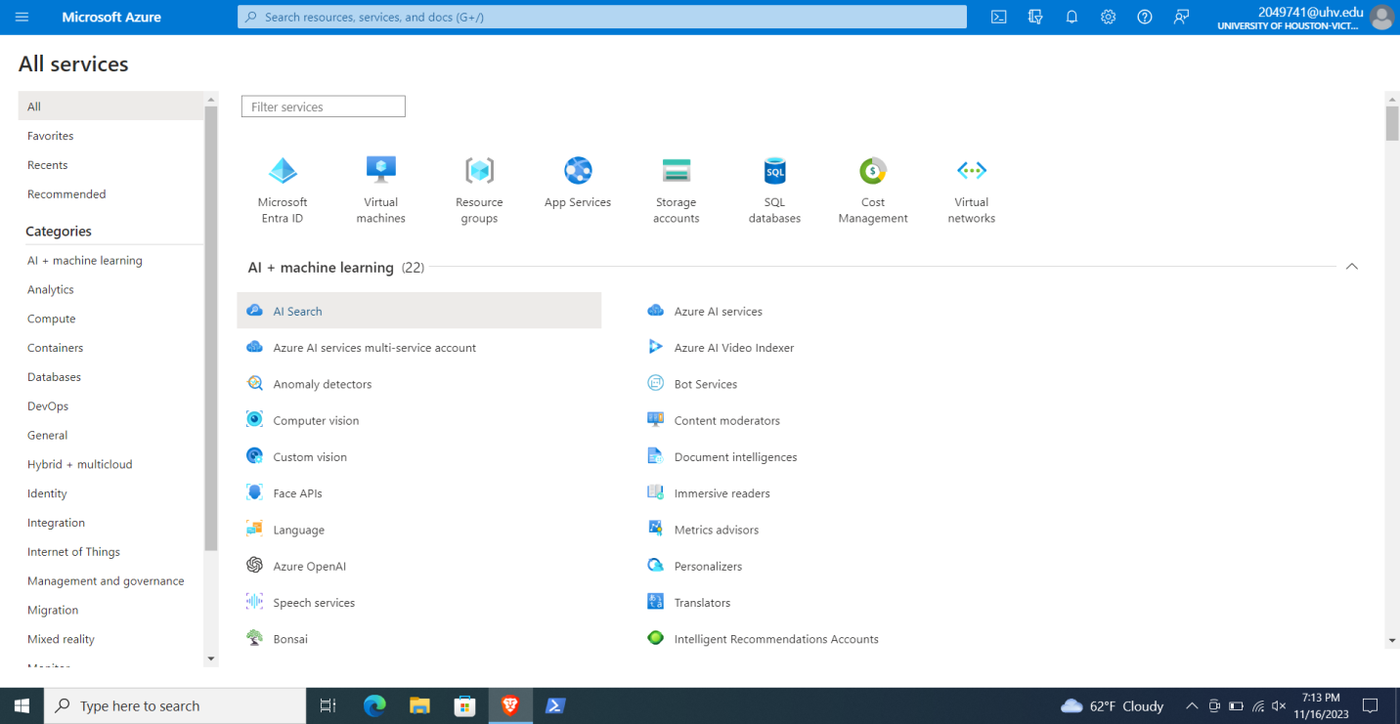

Follow these steps to create your virtual machine:

1. Search for "**virtual machines**" in the search bar and select "**Virtual machines**" under Services.

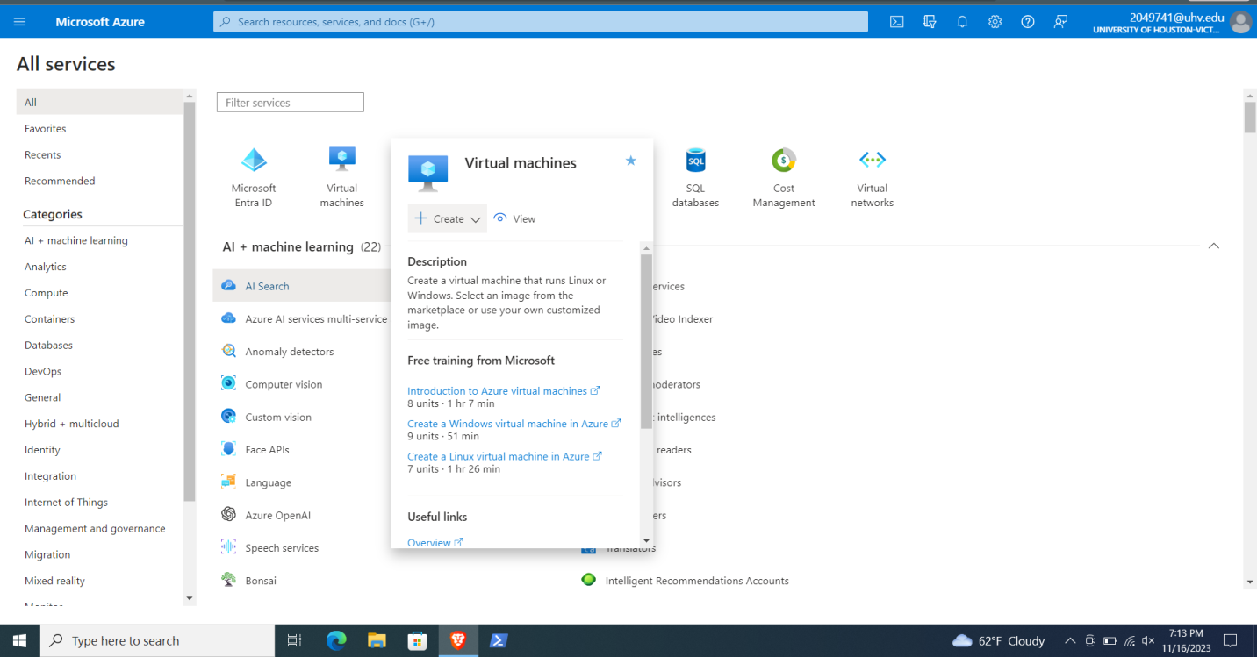

1. In the "**Create a virtual machine**" page, leave the default values under **Instance details** as they are.

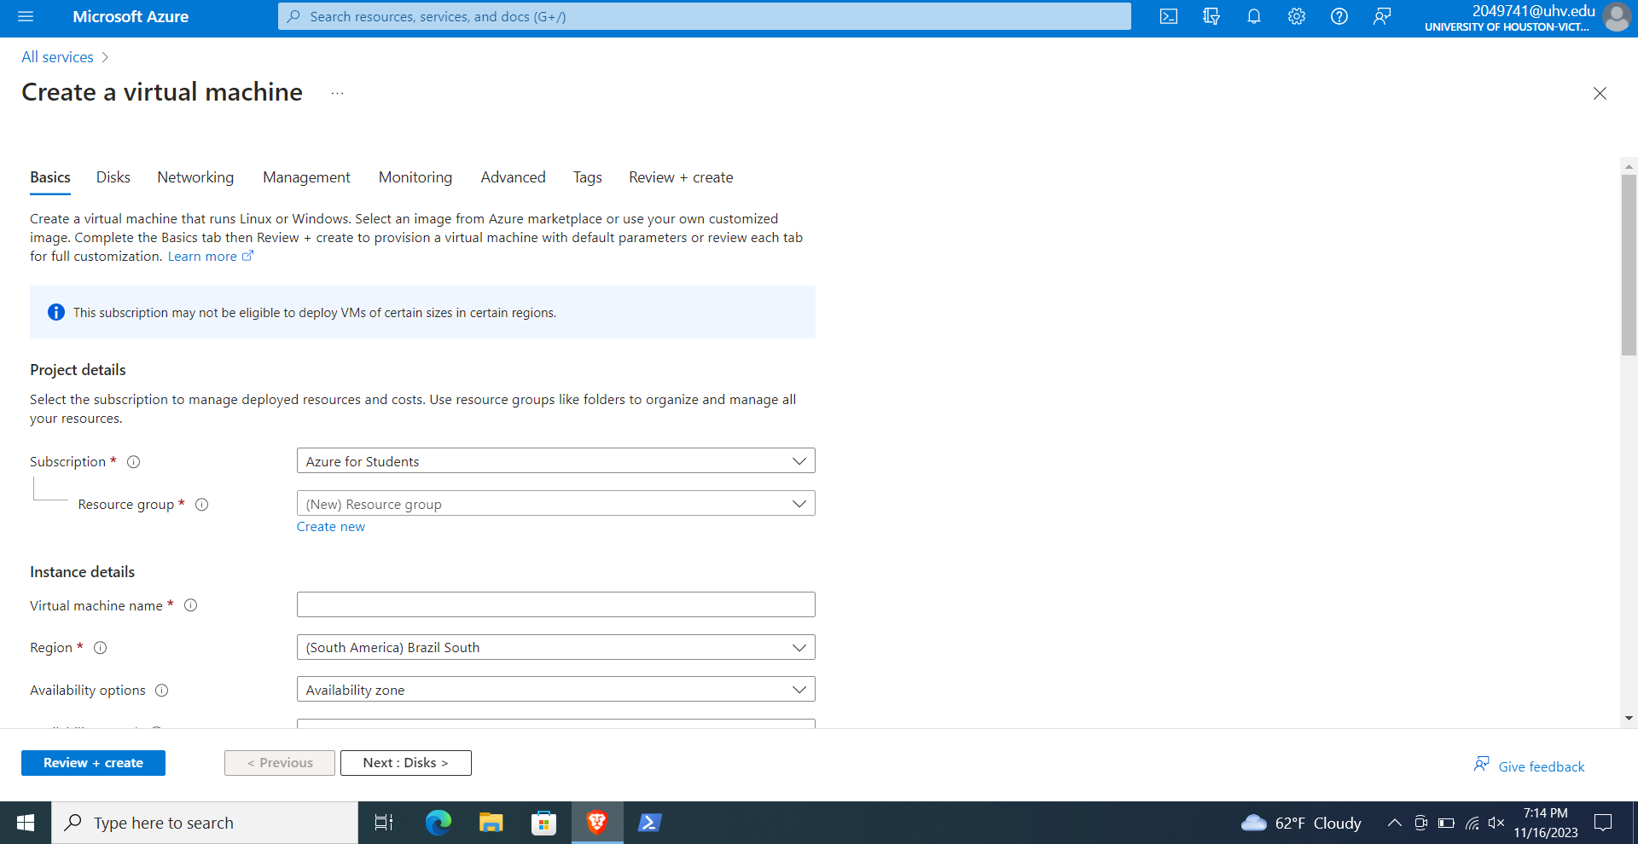

 Choose a preferred name for your **virtual machine**, select a **region** that is closest to your location from the available global regions, and choose the **"[smalldisk] Windows Server 2019 Datacenter - x64 Gen2**" image. Leave the other options as default.

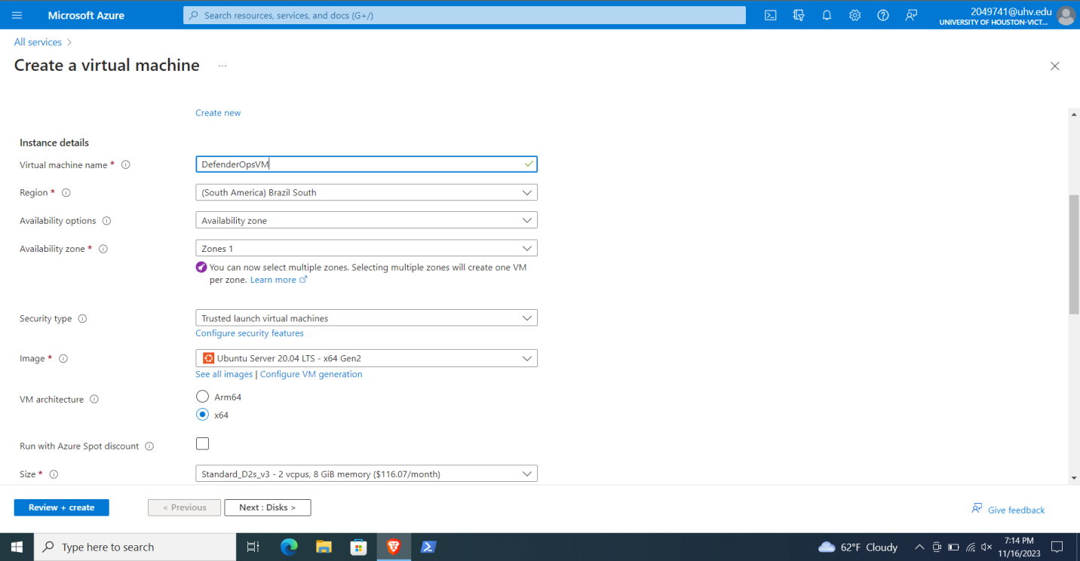

 Under **Administrator accoun**t, provide a username and password of your choice. Remember that the password must be at least 12 characters long and meet the defined complexity requirements. For **Inbound port rules**, select "Allow selected ports" and choose **RDP (3389)** and **HTTP (80)** from the drop-down menu. Leave the remaining settings as default and select the "**Review + create**" button at the bottom of the page.

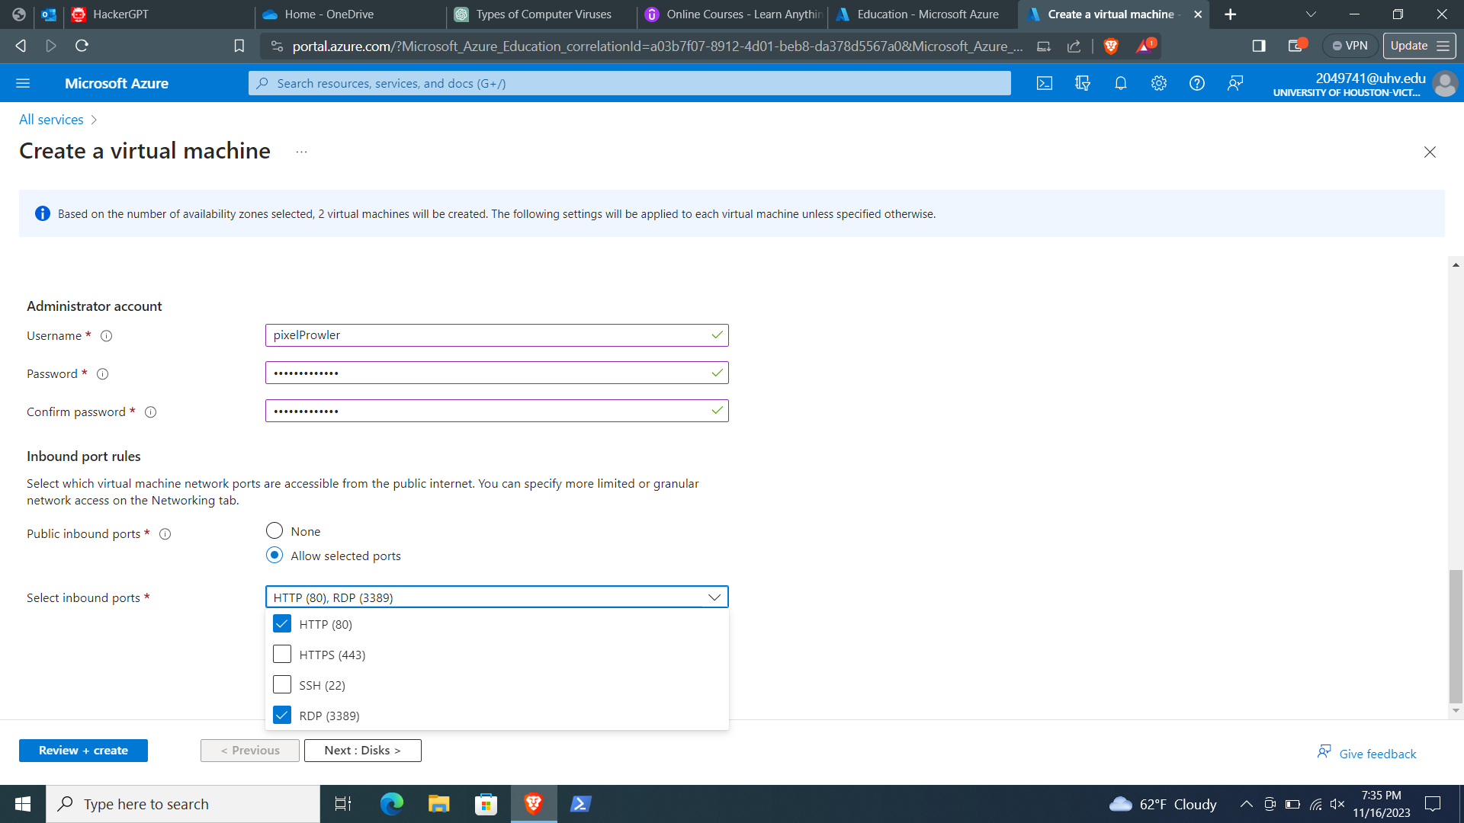

After the validation process completes, select the "**Create**" button at the bottom of the page to begin the deployment of your virtual machine.

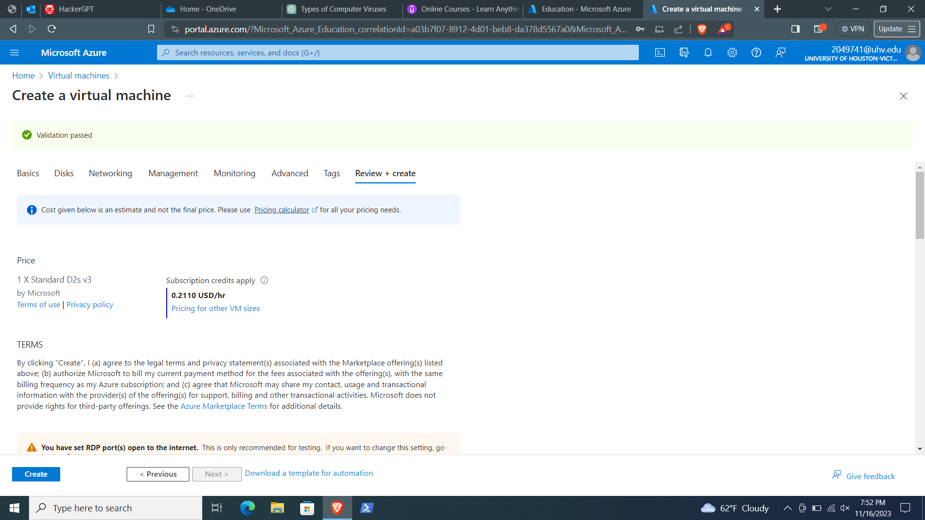

Once the deployment is complete, select "**Go to resource**" to access your newly created virtual machine.

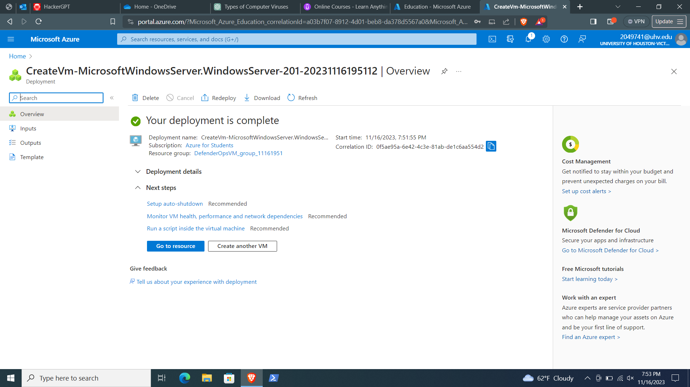

**Step 3: Connect to the Virtual Machine**

Now that your virtual machine is up and running, you need to connect to it using Remote Desktop. Follow these steps:

1. On the **overview** page of your virtual machine, select "**Connect**" and then "**RDP**."

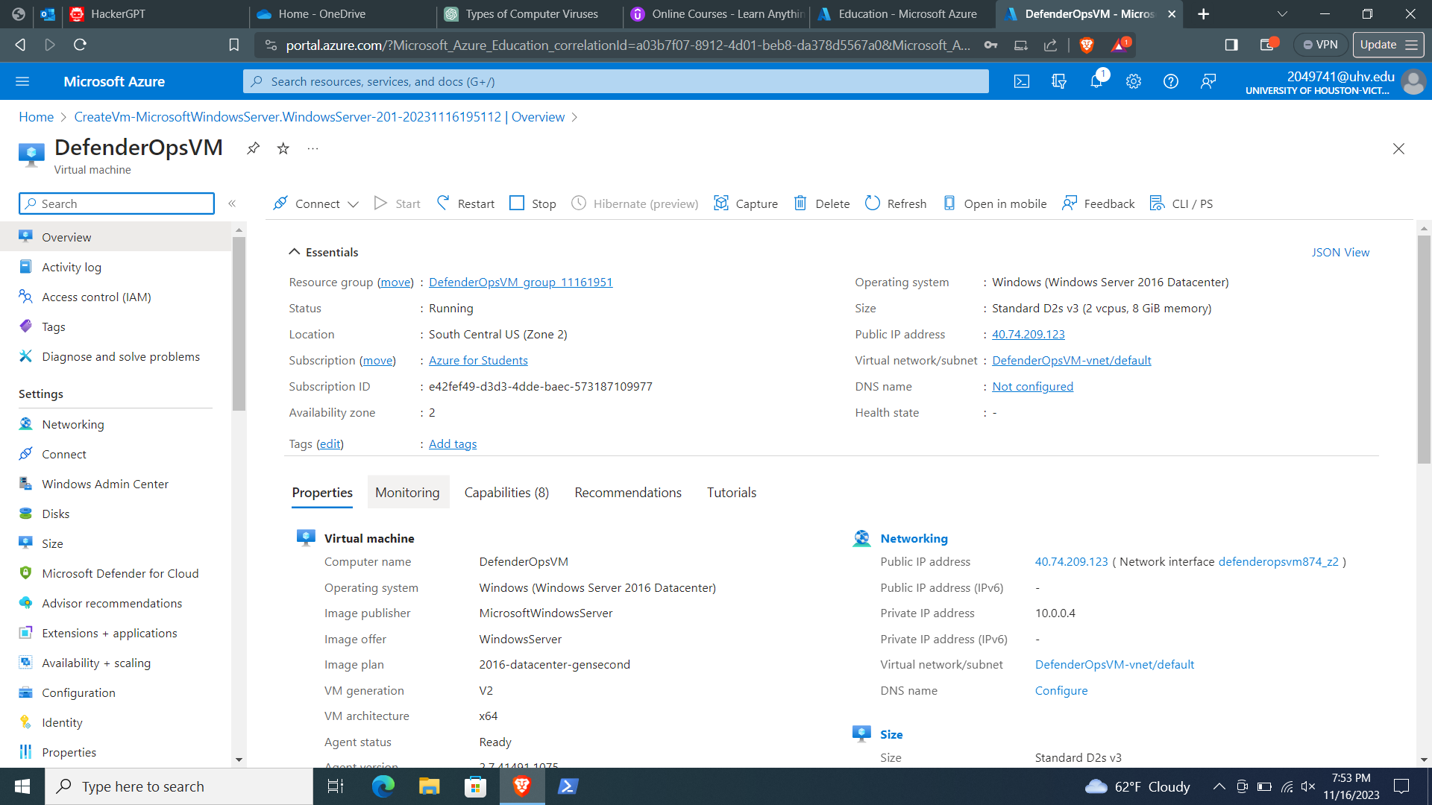

 In the "**Connect with RDP**" tab, keep the default options for connecting by IP address and over port 3389. Click "**Download RDP file**" to retrieve the Remote Desktop Protocol (RDP) file.

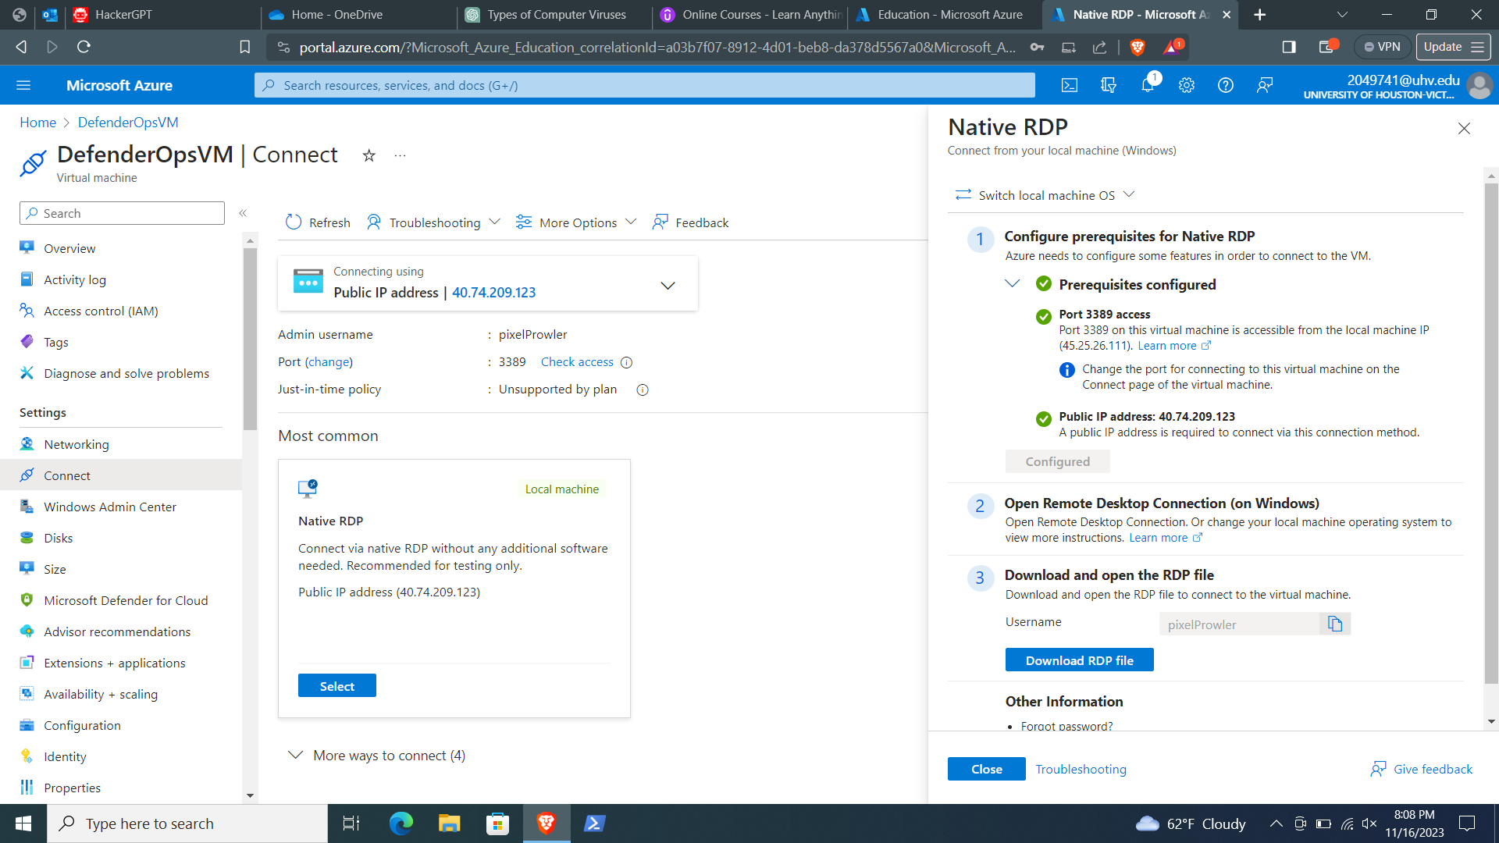

1. Open the downloaded RDP file and click "**Connect**" when prompted.

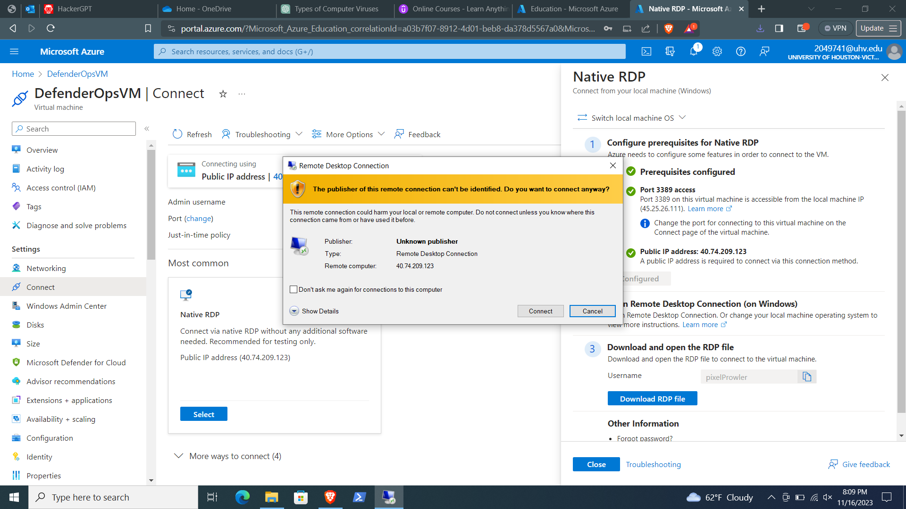

In the **Remote Desktop Connection** window, enter the username as localhost\username (replace "username" with the username you provided during the virtual machine creation process). Enter the password you created for the virtual machine and click "**OK**."

